Machine Learning (CSE 463) Final Report

Ezgi ÇAKIR 20150807005

Şükrü Anıl ÇAKIR 20160808011

Table of Content

Project Objective ________________________________ 3

What is CNN ___________________________________ 3

Dataset ________________________________________ 4

Libraries & Their Usage ________________________ 5

Library Versions ________________________________ 5

Architecture & Technical Details ___________________ 5-6

Results ________________________________________ 6-7

Project Objective

We are implementing gender and age classifier from human images. Reasons of we want to make gender recognition from face images is it is important application in the fields of security, retail advertising and marketing. Gender recognition has large usage area like markets can give relative advertise for their customer according to their gender and age this topic can be extended to calculate statistics to see role women, mans and distribution of their ages in real life. İts also plays an important role in biometric applications, this project can increase the performance of a wide range of applications including identity authentication, search engine, retrieval accuracy, demographic data collection, human-computer interaction, access control, and surveillance.

In smart home technologies age can determine security level for risky areas kitchen bath stairs etc. In smart car technologies ages is also important if driver age is under 18 car turns off itself, for drivers safety. We chose this project because of this diversity in the field of application and bright future of CNN.

What is Convolutional Neural Network?

CNNs are powerful image processing, artificial intelligence (AI) that use deep learning to perform both generative and descriptive tasks, often using machine vision that includes image. A CNN uses a system much like a multilayer perceptron that has been designed for reduced processing requirements.

A [Convolutional Neural Network](https://missinglink.ai/guides/neural-network-concepts/fully-connected-layers-convolutional-neural-networks-complete-guide/) (CNN) has three important building blocks:

● **A convolutional layer** that extracts features from the image or parts of an image

● **A subsampling or pooling layer** that reduces the dimensionality of each feature to focus on the most important elements (typically there are several rounds of convolution and pooling)

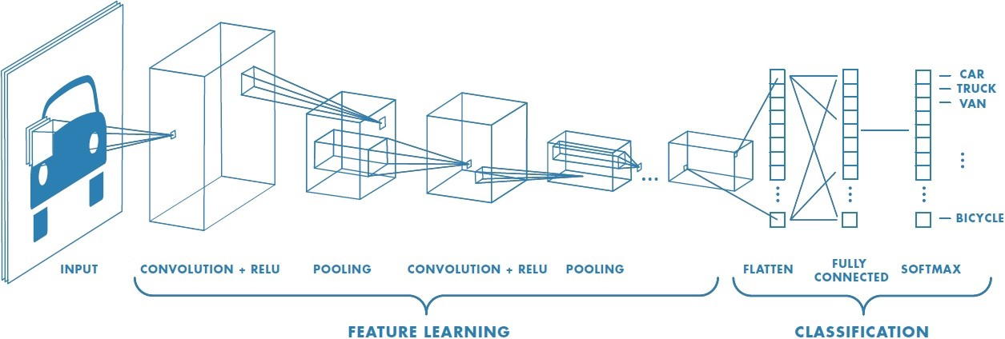● **A fully connected layer** that takes a flattened form of the features identified in the previous layers, and uses them to make a prediction about the image.

Dataset

We have neural network which can predict age and gender. We split our dataset 0.7 percent for training and 0.3 percent for test. In our dataset we have 1572 face image. More Details about our dataset are in below.

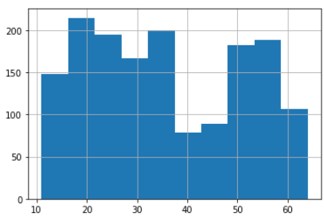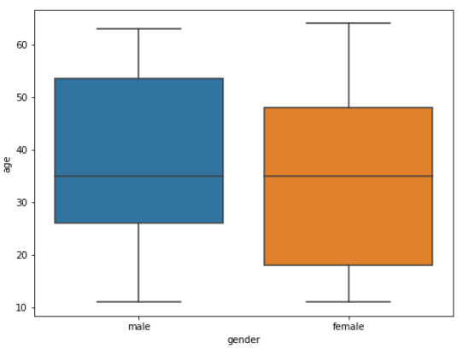

Figure 1 Age Distribution Histogram

Figure 3 Box and whisker plot

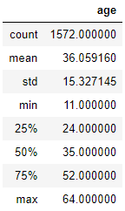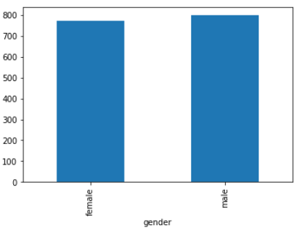

Figure 2 Age Distribution Details

Figure 4 Gender Distribution Histogram

Libraries & Their Usage

* Keras: ML library used for Convolution Layer and Neural Network Layer.
* Numpy: is used for linear algebra calculations.
* Matplotlib: is used for visualizing input & output data.
* Seaborn: is a statistical data visualizing library (boxplot etc).
* PIL: Pillow is an Image Vision Library, we use it for read & write images.
* Pandas: Construct data frame from dictionary.

Library Versions

Our code is work successfully in this library versions:

Python 3.7.4

Numpy Version: 1.16.5

Keras Version: 2.3.0

Pandas Version: 0.25.1

Seaborn Version: 0.9.0

PIL Version: 6.2.0

Architecture & Technical Details

Convolutional Layer

In this layer we make 6 convolutions & pooling.

Neural Network Design

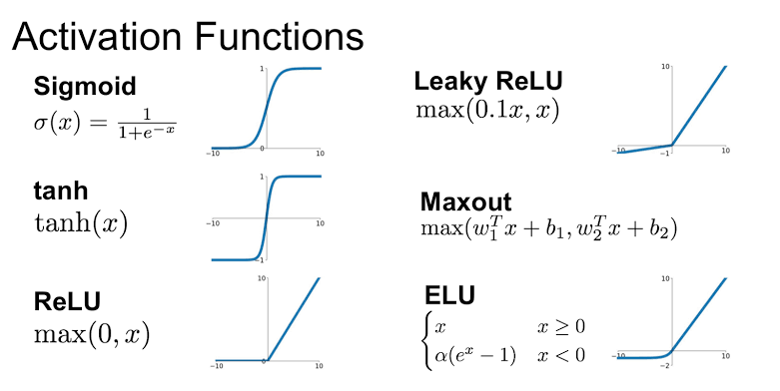We have 6 pooling layer in our network and using ReLu activation function to input layer and Sigmoid function in output layer for age and Softmax function output layer for gender.

For age classification we have 64 neurons in hidden layer & for gender classification we have 32 neurons in hidden layer.

Normalizing Data

Neural Networks were really difficult to train, and making complex models converge in a reasonable amount of time. We have batch normalization to help them converge.

Problem appears in the intermediate layers because the distribution of the activations is constantly changing during training. This slows down the training process, problem which is called internal covariate shift problem. It is appears in the intermediate layers because the distribution of the activations is constantly changing during training. This slows down the training process, Batch Normalization is a method that fight with this problem.

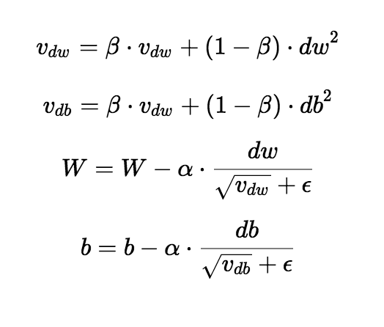Choosing Optimizers

We prefer “RMSprop” optimizer. We using it because it’s giving much better result compare to other optimizer RMSprop optimizer is similar to the gradient descent algorithm with momentum.

The RMSprop optimizer restricts the oscillations in the vertical direction. Therefore, we can increase our learning rate and our algorithm could take larger steps in the horizontal direction converging faster.

Results

We setup our model and train it in 6 epoch with batch size 64. Each epoch takes approximately 300 seconds. After this training we have this as result.

As we can see each in epoch Train accuracy is increase and try to over-fit train data. After epoch 4, Validation results increase significantly. We suppose 10-15 epoch (50-75min) make this result more accurate.

Age is a challenging Feature for our model. Our model can make big success in Train Data but Validation Check not satisfy us. We try to increase & decrease our dataset length to make it more successful, but we can’t try that in bigger epochs (because it very time consuming). We believe 15 epoch (75min) make this prediction more accurate.

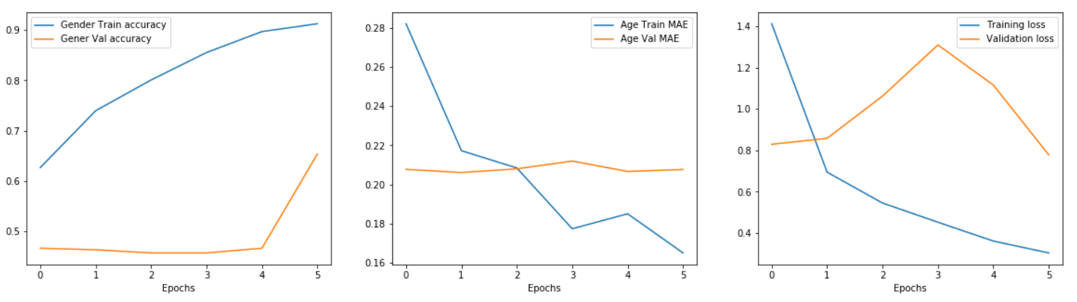According to last figure, we can say that our model works correctly, loss of training set decrease logarithmically.

After Training we compare results with real values. 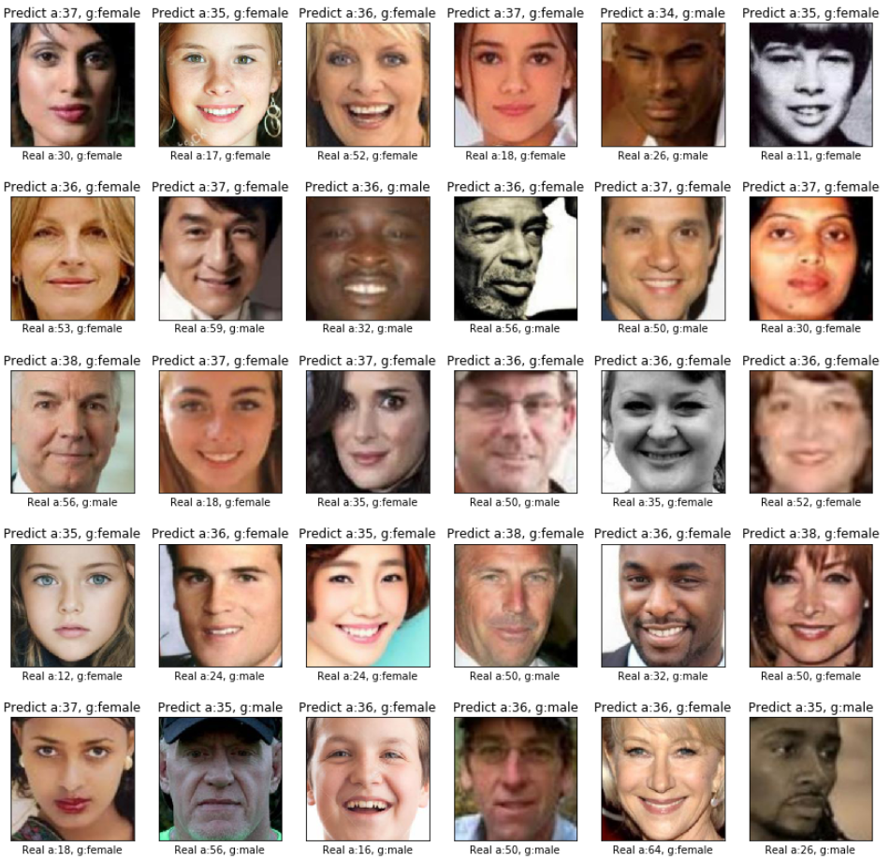Labels above the images are Model’s result & labels below are Real values. Model is successful in gender classification. In age prediction results are near “**average age** (36)”. We observe that some young people are labelled age **below** **average** & old people labelled **above** **average**.